Name
Tutor
Course
Date
Assessment 1
Integrated marketing communications is a concept that is usually used in marketing. This defined as an approach or a platform that is used to bring together customers. This is done by providing them an experience in interacting with various brands or enterprises. This platform brings together all aspects of marketing communication, such as an advertisement, promotion of sales, direct marketing, public relations and social media. Thought various methods, tactics, channels, and media so that they work together. This is also a pathway that ensures that all the messages and communications are consisted and are directed to the customer. Thus, they are customer centered. Therefore, integrated marketing communication is the best form of marketing products.
Five benefits of integrated marketing communications.
1. It develops trusts. By integrated messaging and also keeping the consisted, builds trust with the customers or the audience that one intends to reach out. Thus, customers will give the benefit of out by opening the link or the message to know more about the product.
2. It eliminates the confusion. Bringing together your campaigns into one basket or pool make the messages you are conveying to customers or clients simple and clear. This makes the customer understand your campaigns as a company or business and they will definitely react the way you want. Thus, removing any form of confusion.
3. Effectiveness. Integrating the campaign becomes more effective. This is by making your messages consistent through many channels, enforces the message and makes it be more powerful.
4. It saves money. When you integrate the campaigns one eliminated duplication since you can be able to share in many channels. Thus saving your money and time. This is because of the high cost that comes with photography, content, and graphics to any company or business.
5. It increases ones morale. Integrating the campaigns make the teams that are involved share their talents by ensuring that they are the best in communication by ensuring that there is consistency. This brings good results hence boosting the morale of the team. Also, the task of integrating communication across many channels make that team expert and ready to do the next task.
The following are the most important incentives of integrated marketing communication this year. First, competitive positioning and secondly, social media.
Competitive positioning is a very critical marketer. It explains how one can differentiate his products or offering with this of the competitors and come up with the best value in the market. Competitive positioning will identify the market position and provide an offer on the product or brand. Then, it targets the customers who need the brand and inspires those who are not interested in the product. And lastly, it created advertisement campaigns and strategies by placing the earned and paid impressions in the marketplace.
Social media is another important tool for marketing. This is because it is accessible to many people since many businesses have gone online. Thus, many people can be reached via social media platforms such as Facebook, Twitter, and Instagram just to name a few.
Effective ad
An effective and is an ad that worked in the sense that is reached many customers or the target's audience and the response was good. 6his is an example of an effective ad that was placed on Facebook.

This ad worked. This was an advert that was marketing the various varieties of food from Nature Box. The image was posted on Facebook and on the daily magazines. The optimal size of this news feed was 1200*650 pixels which is a good quality of an image. The image is visual since it clearly shows what you expect to get and call for a free sample of the brands of foods offered. It is relevant in that everyone likes snacks and anyone who sees this will truly seek to have one. It is valuable since this ad is filled with value. First free trial catches the eye of many and secondly, talks about the health gain of the products which is a concern to many customers. Lastly, it has got a clear call-to-action. This is portrayed by Nature Box calling for anyone who is interested to get a free trial of the product. This ad did not get the attention of many since not all people like the snacks.
Critiques
However, this ad will not get attention of people who does not do with snacks. Also, this product is only limited to high class and middle earning individual. Therefore it is hard for an average or low class people to afford. The platform in which it is has been posted is not accessible to many people or potential customers.
Not effective ad

The following ad is not effective.

This an advert on Rick’s professional Auto Dealings that was placed on Facebook and on the radio stations. It was broadcasted on a radio station but it did not attract many of the customers. The image was not visual and did not get to the customer. It is not relevant to many since not everybody owns a car and less frequently people by car material. Lastly, Rick’s professional auto dealings do not have a call to action. Such giving customers some gifts or favorers.
Critique
The ad will not bear any fruits since not all the people likes vehicles and will like selling vehicles. The ad is small and invisible to clients. Finally the platform on which it has been laced is not accessible by many people. The company selects a certain class of people, high class to be customer since the pricing of cars is not affordable to all people in the society.
Question 2
Rick’s professional Auto Dealings professional is a company that deals with selling and repair of vehicles. It I found in United States, Texas.
Target audience profile
Target audience are the potential customers of Rick’s Auto dealings. This company targets the citizens of United States and Mexico. Since the company operates in the two countries. It sells different brand of vehicle from personal cars to big Lorries.
Communication objective(s)
1. To create awareness. Communication creates awareness about Rick’s company to the potential customers.
2. It provides information on the pricing and the latest vehicles in the market.
3. It projects the image of the Rick’s dealings in good light. This is by providing positive information concerning the company.
4. Communication explains the importance of vehicles. It attracts the more consumers of the wines to purchase various vehicles in Rick’s dealings thus increasing the sales.

Overall communications strategy
This is a plan on how to marketing Rick’s auto dealings. It has the following elements. First, it has written communication with the brand and some information of Rock’s dealings. Secondly, it has other communication forms such as which are either visual like images or audio. The audio can be used in radio stations during marketing the brands. Lastly, the communication strategy does not include other components of marketing. It should be detailed and straightforward. Therefore, communication strategy looks on the small strategies that at the end have a big impact.
Positioning
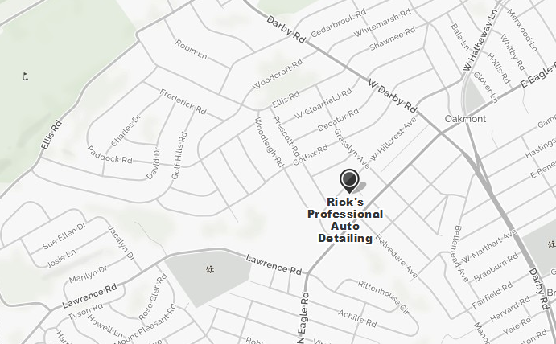

Communications tactics
The company will be sending the messages about the company d the various types of products they offer via emails. This emails will be obtained from a form that potential clients and customers fill during purchase or making inquiry. Also, customers should be texted in their personal cell phones. Finally communication should be done in print media and weeding or parties.
Communications mix to support your strategies
This is the ways you want to get the message across, it includes external and internal communication. External communication includes press such as radio, press release, and opinion editorial. Secondly, online example email newspapers and websites. Thirdly, advertising such as print, radio and television and finally public relations such as events and conferences.
Evaluation
After the marketing campaign is over the company should audit the marketing strategies to see if they were successful. They should look the input, that the amount of resources the invested in the campaign. Against the output, which is the results or sales. Of the output is greater than the input, then the campaign was a success. If not then the company should abandon the campaign.
Kalala Winery
I have chosen Kalala vineyard brand. Which is a producer of wines using organic grapes it is located in Colombia and Canada?
Target audience profile
This is people or the consumer of Kalala wines. They constitute people, organization and entertainment clubs in Colombia and Canada. In this section, we shall describe the name of the targeted audience, the location for easy delivery of the Kalala wines and the contacts of the targeted customers. Kalala wines targets markets in British Colombia, Canada, and India. It provides different brand for customers in various sizes and prices.
Communication objective(s)
1. To create awareness. Communication creates awareness about the existence of Kalala winery to its potential customers.
2. It provides information and knowledge about Kalala wine, such as the health benefits that come with consuming the wines.
3. It projects the image of the Kalala winery in good light. This is by providing positive information concerning the company.
4. Communication positively affects the attitude of the consumers or the targeted audience towards the brand of Kalala winery.
5. Communication affects the sale of the Kalala winery. It attracts the more consumers of the wines to purchase the brand of the Kalala wines thus increasing the sales.
Overall communications strategy
This is a plan on how to market Kalala winery. It has the following elements. First, it has written communication with the brand and some information of Kalala winery. Secondly, it has other communication forms such as which are either visual like images or audio. The audio can be used in radio stations during marketing the brands. Lastly, the communication strategy does not include other components of marketing. It should be detailed and straightforward. Therefore, communication strategy looks on the small strategies that at the end have a big impact.
Positioning (describe and illustrate with a map) and key messages
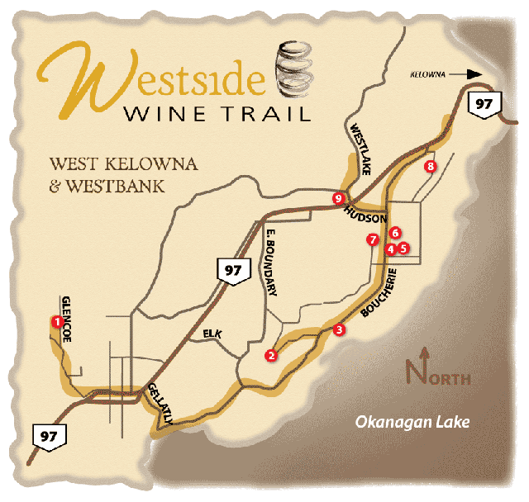
The target audience is the people of Colombia and Canada. The key messages for the target audience include; I will like the audience to know the health benefits of Kalala winery. Also, the where the wines can be found, that is the various towns and wines shops. For example, ‘hello customer, Kalala wines produces wines that are prepared from organic wines. They are rich in vitamin B and medicinal to stomach problems’. “Our brand is found in all wines shops, supermarkets and clubs across the country at a cheaper price.” I will like the customers to have a good impression concerning the products.
Communications tactics
In order that there is communication consistency. The client will be sending messages directly using their mobile phones every weekend. This is because of this in the time when most of the people drink wine. An email will be sent. Since when one buys the brand he or she fill a small for that has the phone number, location, and email. Communication can also be done on newspapers, social media such as blogs and media. Also in special events such as the weddings and parties.
Communications mix to support your strategies
This is the ways you want to get the message across, it includes external and internal communication. External communication includes press such as radio, press release, and opinion editorial. Secondly, online example email newspapers and websites. Thirdly, advertising such as print, radio and television and finally public relations such as events and conferences.
Suggestions for creative concept and execution
This objective will be achieved by raising funds and creating awareness, committing and dedicating self. The target audience will reach via advertisements on social media, print media and conducting roadshows. This strategy has used the collect and the right tools for marketing that enables us to reach the targeted customers. In the internal setting, I reached the collect people in the organization by writing booking appointment with the head of communication and marketing and explain the communication strategy. The manager understood the plan and executed what was required.
Budget allocation
In press, I will use $ 35,000 since the majority of the people get information using the press. Also, it is a very expensive form of communication. Second, online I will use 10,000 since it is very cheap and can be done with anybody. Advertising I will use $ 30,000 since it is very expensive to add an ad in print, radio or television. Also, it is convenient for many people. The print I will use $25,000 because it is expensive. Lastly, I will use public relation $10,000 because it is cheap.
Describe the actual or perceived value created for the target audience
The target audience will perceive the value of Kalala wines to be fairly expensive because of the following reasons.
• The form of advert that is employed is expensive.
• Accessibility of the wines. They are accessible everywhere.
• The health benefits that are associated with the Kalala winery.
• Communication mix that is used.

